2.13 Cooperative and Participative

- Cooperative/Collaborative v. competitive
- Cooperatives eg. Pubs, bakeries, wind turbines, other countries

Website Education Resources from The Cooperative College

Film Collaborative Consumption groundswell – What’s mine is yours
https://www.youtube.com/watch?v=VuiIAMQTw_g

Collaborative Consumption
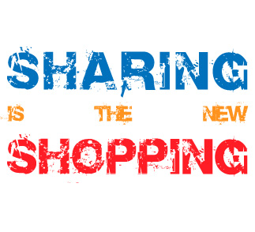
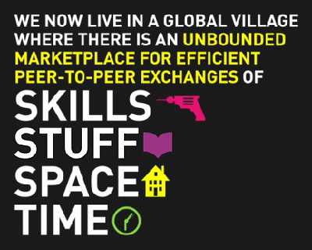

  - Throw-away society
  - Renting, hiring, borrowing, sharing the consumable product not buying it.
  - So the producer, not consumer, owns the product and has to repair, restore and recycle. The consumer buys the service not the product eg. The consumer buys warmth not the heater or the heating.

Participative and Consensual
- Move decision-making power and governance that affects local communities to lower levels.
- Global governance – in response to global change (across borders)
  - networking, subsidiary, coordinating state.
- Cooperation and consensus-building, partnership decision-making.
- Increased power and involvement of civil society.
- Transparent process with consensus by whole society.

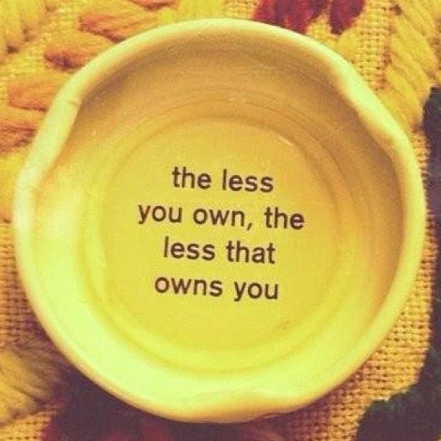
De-Ownership

- Community ownership v. personal ownership

Film De-ownership – Ecomodo
http://ecomodo.com/pages/index.aspx

If sustainable technologies are about the what of the living economy, local and shared ownership designs are about the who: who will own the productive capacity of the nation, who will control it, and who will benefit from the wealth created.

Ownership is something most of us think little about, yet its allocation is basic to our daily lives. Ownership defines the shape of our days: where we work for 40 hours (or more) each week, whether we’re empowered or belittled by our work, how much anxiety we suffer over our debts, whether we’re able to own a home or be secure in retirement. Questions about who owns the wealth-producing infrastructure of an economy, who controls it, and whose interests it serves are among the largest issues any society can face, and critical to creating shared prosperity.

Local and shared ownership, key tools for keeping wealth local, help to form the girders of a framework that can unite a community wealth movement as a social counterpart to the sustainability revolution.

Participation



